Eclipse Database Setup for SMEAR Test
The Eclipse software uses an Access 97 database. Some hunting suggests that this has a lot of useless, repeated data. This document has some hints for working through the tables to get at the raw data.

The Batch table.
Samples are stored as batches. Note the one that we are interested in from the “Recall Batch” dialog that comes up from the Eclipse “File Open” menu:
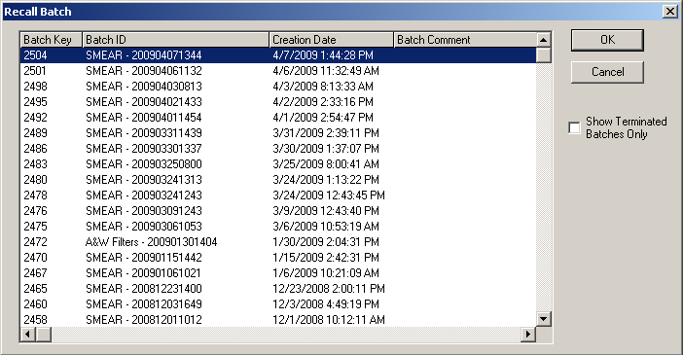
When we look at the segments of the ‘Batch’ table, we see lots of redundant information:
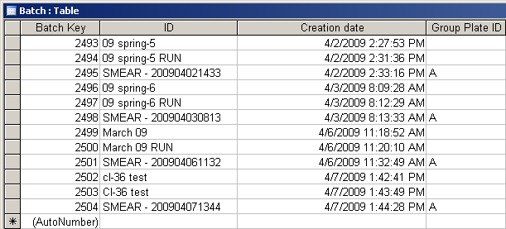
But note that the ones we want seem to have an “A” in the “Group Plate ID’ Field.
The next step is to get the sample information. For that we need the “Sample Aliquots” Table

The “Sample Aliquots” Table
The key will be to search the “Sample Aliquots” table for all instances where the “Batch Key” field matches our desired Batch Key. For each compliant record we want the “Aliquot Sample Key”, the “Creation Time” and the “Alias ID”. The relevant SQL query might be:
SELECT “Batch Key”, “Aliquot Sample Key”, “Creation Time”, “Alias ID” from TABLE “Sample Aliquots” where “Batch Key” =2504

Getting the raw acquisition data
The raw acquisition data is in the table “LB Acquisition data”. We want to get the data associated with each “Aliquot Sample Key” that we Here we might want to do something like this
SELECT “Aliquot Sample Key”, “LB Acquisition Data Key”, “Alpha Count”, “Alpha Count Unc” ”, “Beta Count”, “Beta Count Unc”, “LiveTime” from TABLE “LB Acquisition data” where “Aliquot Sample Key” = 17850

Getting the activity from the system
If desired one could get analyzed data from the “LB Analysis Data” table with something like this
SELECT “LB Acquisition Data Key”, “Alpha Specific Activity”, “Alpha Specific Activity” from TABLE “LB Analysis Data” where “LB Acquisition Data Key” = 17892

